**Mali country profile**

Published

26 August

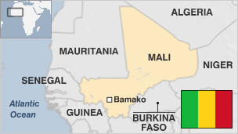

**Once home to several pre-colonial empires, the landlocked, arid West African country of Mali is one of the largest on the continent. For centuries, its northern city of Timbuktu was a key regional trading post and centre of Islamic culture.**

But this prominence has long since faded.

After independence from France in 1960, Mali suffered droughts, rebellions, a coup and 23 years of military dictatorship until democratic elections in 1992.

In 2013, France intervened militarily upon the government's request following the capture of the town of Konna and its troops overran Islamist strongholds.

Authorities agreed a United Nations-sponsored ceasefire with Tuareg separatists in 2015, but parts of the country remain tense, with Tuareg rebels sporadically active.

Meanwhile, a jihadist insurgency in Mali's north and central regions continues.

Mali is renowned worldwide for having produced some of the stars of African music, most notably Salif Keita.

* Read more [country profiles](http://news.bbc.co.uk/1/hi/country_profiles/) - Profiles by [BBC Monitoring](http://www.bbc.co.uk/monitoring)

**Head of State: Assimi Goita**

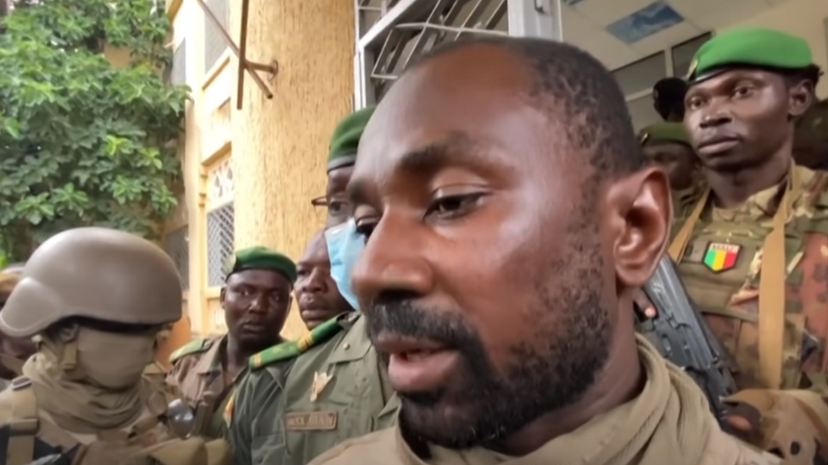image copyrightFrance 24/YouTube

Colonel Goita is head of a military council that seized power in August 2020, as Mali struggled with mass protests over corruption, electoral probity, and a jihadist insurgency that has made much of the north and east ungovernable.President Ibrahim Boubacar Keita, who took office in September 2013, proved unable to unify the country or face down the insurgency.

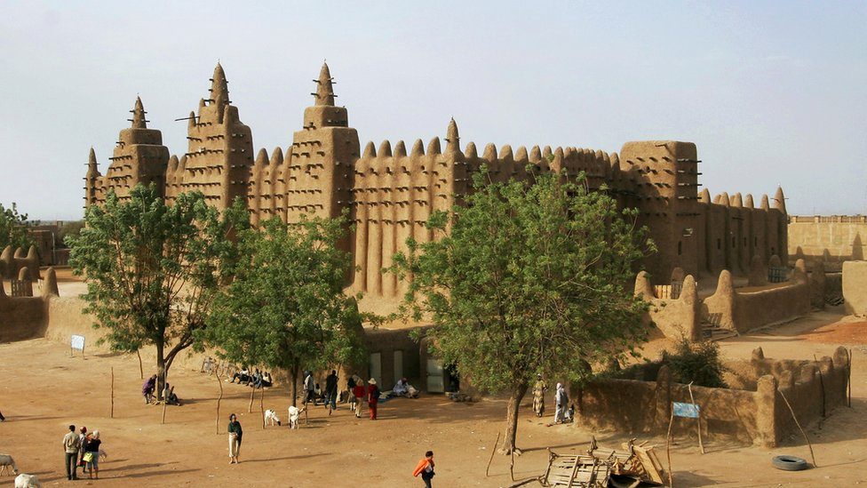image copyrightGetty Images

image captionThe great mosque of Djenne is one of the continent's most notable landmarks

The media environment in Bamako and the south is relatively open, but the presence of armed militant groups in the north poses dangers for media workers, says Freedom House.

Radio is the leading medium. There are hundreds of stations, run by the state as well as by private operators.

# Mali profile - Timeline

Published

26 August

## A chronology of key events:

**11th century** - Empire of Mali becomes dominant force in the upper Niger basin, its period of greatness beginning under King Sundiata in 1235 and peaking under Mansa Musa who ruled between 1312 and 1337 and extended empire to the Atlantic.

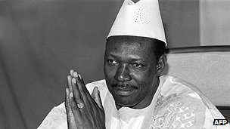image copyrightAFP

image captionMoussa Traore took power in a 1968 coup and ruled until 1991

**14th-15th centuries** - Decline of the Empire of Mali, which loses dominance of the gold trade to the Songhai Empire, which makes its base in Timbuktu - historically important as a focal point of Islamic culture and a trading post on the trans-Saharan caravan route.

**Late 16th century** - Moroccans defeat the Songhai, make Timbuktu their capital and rule until their decline in the 18th century.

**19th century** - French colonial advance, and Islamic religious wars which lead to creation of theocratic states.

**1898** - France completes conquest of Mali, then called French Sudan.

**1959** - Mali and Senegal form the Mali Federation, which splits a year later.

## Independence

**1960** - Mali becomes independent with Modibo Keita as president. It becomes a one-party, socialist state and withdraws from the Franc zone.

**1968** - Keita ousted in coup led by Lieutenant Moussa Traore.

**1977** - Protests erupt following Keita's death in prison.

**1979** - New constitution provides for elections; Traore re-elected president.

**1985** - Mali and Burkina Faso engage in border fighting.

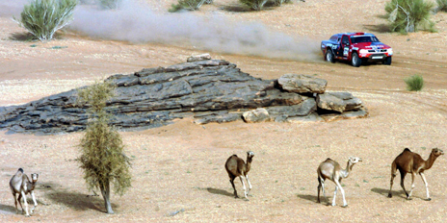image copyrightGetty Images

image captionMali used to be on the route of the gruelling Paris to Dakar rally

**1991** - Traore deposed in coup and replaced by transitional committee.

## Democracy

**1992** - Alpha Konare wins multiparty elections to become Mali's first democratically-elected president.

**1995** - Peace agreement with Tuareg tribes leads to return of thousands of refugees.

**1999** - Former President Moussa Traore sentenced to death on corruption charges, but has his sentence commuted to life imprisonment by President Konare.

**1999** October - Several people killed in fighting in the north between members of the Kunta tribe and an Arab community over local disputes.

**2000** February - Konare appoints former International Monetary Fund official Mande Sidibe prime minister.

**2001** December - Manantali dam in southwest produces its first megawatt of hydro-electricity, 13 years after it was completed.

## Amadou Toure

**2002** April - Amadou Toumani Toure elected president by landslide. Poll is marred by allegations of fraud.

**2002** September - France says it will cancel 40% of debts owed to it by Mali, amounting to some 80m euros ($79m, £51m).

**2002** October - Government resigns, without public explanation. New "government of national unity" is unveiled.

**2003** August - Clashes between rival Muslim groups in west kill at least 10 people.

**2004** April - Prime Minister Mohamed Ag Amani resigns and is replaced by Ousmane Issoufi Maiga.

**2004** September - Agriculture minister says severe locust plague has cut cereal harvest by up to 45%.

**2005** June - World Food Programme warns of severe food shortages, the result of drought and locust infestations in 2004.

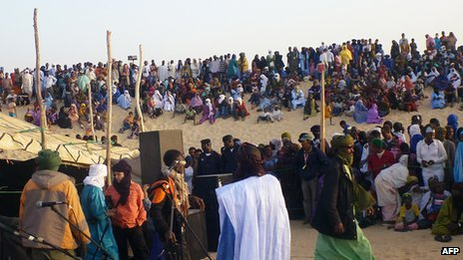image copyrightAFP

image captionMali's popular annual Desert Festival - described as a Saharan Woodstock - was moved closer to Timbuktu because of security concerns

**2006** June - The government signs an Algerian-brokered peace deal with Tuareg rebels seeking greater autonomy for their northern desert region. The rebels looted weapons in the town of Kidal in May, raising fears of a new rebellion.

**2007** April - President Toure wins a second five-year term in elections.

**2007** July - The ruling coalition, Alliance for Democracy and Progress (ADP), strengthens its hold on parliament in elections.

## Rebel activity

**2007** August - Suspected Tuareg rebels abduct government soldiers in separate incidents near the Niger and Algerian borders.

**2008** May - Tuareg rebels kill 17 soldiers in attack on an army post in the northeast, despite a ceasefire agreed a month earlier.

**2008** December - At least 20 people are killed and several taken hostage in an attack by Tuareg rebels on a military base in northern Mali.

**2009** February - Government says the army has taken control of all the bases of the most active Tuareg rebel group. A week later, 700 rebels surrender their weapons in ceremony marking their return to the peace process.

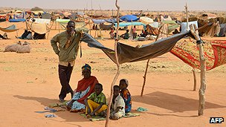image copyrightAFP

image captionConflict in the north of the country prompted thousands to flee

**2009** May - Algeria begins sending military equipment to Mali in preparation for a joint operation against Islamic militants linked to al-Qaeda.

**2009** August - New law boosts women's rights, prompts some protests.

**2010** January - Annual music event - Festival in the Desert - is moved from a desert oasis to Timbuktu because of security fears.

**Terror challenge**

**2010** April - Mali, Algeria, Mauritania and Niger set up joint command to tackle threat of terrorism.

**2012** January - Fears of new Tuareg rebellion following attacks on northern towns which prompt civilians to flee into Mauritania.

**2012** March - Military officers depose President Toure ahead of the April presidential elections, accusing him of failing to deal effectively with the Tuareg rebellion. African Union suspends Mali.

**2012** April - Tuareg rebels seize control of northern Mali, declare independence.

Military hands over to a civilian interim government, led by President Dioncounda Traore.

**2012** May - Junta reasserts control after an alleged coup attempt by supporters of ousted President Toure in Bamako.

Pro-junta protesters storm presidential compound and beat Mr Traore unconscious.

The Tuareg MNLA and Islamist Ansar Dine rebel groups merge and declare northern Mali to be an Islamic state. Ansar Dine begins to impose Islamic law in Timbuktu. Al-Qaeda in North Africa endorses the deal.

**2012** June-July - Ansar Dine and its Al-Qaeda ally turn on the MNLA and capture the main northern cities of Timbuktu, Kidal and Gao. They begin to destroy many Muslim shrines that offend their puritan views.

**2012** August - Prime Minister Cheick Modibo Diarra forms a new government of national unity in order to satisfy regional demands for a transition from military-dominated rule. The cabinet of 31 ministers includes five seen as close to coup leader Capt Amadou Sanogo.

**2012** Autumn-Winter - Northern Islamist rebels consolidate their hold on the north. They seize strategically important town of Douentza in September, crossing into the central part of Mali and closer to the government-held south-west.

**2012** November - The West African regional grouping Ecowas agrees a coordinated military expedition to recapture the north, with UN and African Union backing. Preparations are expected to take several months.

**2012** December - Prime Minister Cheick Modibo Diarra resigns, allegedly under pressure from army leaders who oppose plans for Ecowas military intervention. President Traore appoints a presidential official, Django Sissoko, to succeed him. The UN and US threaten sanctions.

## French intervention

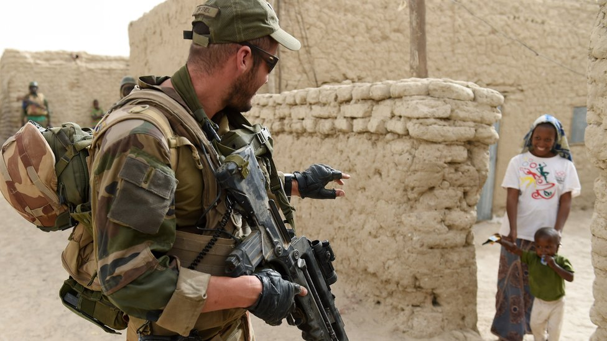image copyrightAFP/Getty Images

image captionFrench troops have been helping the country fight jihadists since 2013

**2013** January - Islamist fighters capture the central town of Konna and plan to march on the capital. President Traore asks France for help. French troops rapidly capture Gao and Timbuktu and at the end of the month enter Kidal, the last major rebel-held town. European countries pledge to help retrain the Malian army.

**2013** April - France begins withdrawal of troops. A regional African force helps the Malian army provide security.

**2013** May - An international conference pledges $4bn to help rebuild Mali.

**2013** June - Government signs peace deal with Tuareg nationalist rebels to pave way for elections. Rebels agree to hand over northern town of Kidal that they captured after French troops forced out Islamists in January.

**2013** July-August - Ibrahim Boubacar Keita wins presidential elections, defeating Moussa Mara.

France formally hands over responsibility for security in the north to the Minusma UN force.

**2013** September - President Keita appoint banking specialist Oumar Tatam Ly prime minister.

**2013** September-November - Government relations with Tuareg separatists in the north steadily worsen, with occasional clashes.

**2013** December - Parliamentary elections give President Keita's RPM 115 out of 147 seats.

France announces 60% reduction in troops deployed in Mali to 1,000 by March 2014.

**2014** April - President Keita appoints former rival Moussa Mara prime minister in a bid to curb instability in the north.

**2014** May - Fragile truce with Tuareg MNLA separatists breaks down in north. Separatists seize control of Kidal city and the town of Menaka, Agelhok, Anefis and Tessalit.

**2014** September - Government, separatists begin new round of talks in Algeria to try end conflict over northern Mali, or Azawad as the secessionists call it.

Separatist MNLA opens an ''Azawad embassy'' in the Netherlands.

**2014** October - Nine UN peacekeepers killed in the north-east - the deadliest attack so far on its mission in Mali.

**2015** January - Mali's health minister says the country is free of the Ebola virus, after 42 days without a new case of the disease since October.

**2015** April - Upsurge in fighting as Coordination of Azawad Movements northern rebels clash with UN peacekeepers in Timbuktu and seize town of Lere, try to recapture Menaka from pro-government militia.

**2015** May - French troops kill leading al-Qaeda commanders Amada Ag Hama and Ibrahim Ag Inawalen in northern raid. Both were suspected of kidnapping and killing French citizens.

A peace accord to end the conflict in the north of Mali is signed by the government and several militia and rebel factions.

**2015** June - Government and ethnic Tuareg rebels sign peace deal aimed at ending decades of conflict. The government gives the Tuareg more regional autonomy and drops arrest warrants for their leaders.

**2015** July - Craftsmen in Mali working for the United Nations rebuild the world-renowned mausoleums in Timbuktu which were destroyed by Islamists in 2012.

**2015** August - Seventeen people killed in attack by suspected Islamist militants on a hotel in the central Malian town of Sevare

**2015** November - Islamist gunmen attack the luxury Radisson Blu hotel in the capital Bamako, killing 22.

**2016** August - Several attacks on foreign forces. More than 100 peacekeepers have died since the UN mission's deployment in Mali in 2013, making it one of the deadliest places to serve for the UN.

A Malian jihadist is found guilty of ransacking the fabled desert city of Timbuktu. He expressed regret in the unprecedented trial before the International Criminal Court.

**2017** January - At least 37 people are killed by a car bomb at a military camp in Gao housing government troops and former rebels brought together as part of a peace agreement.

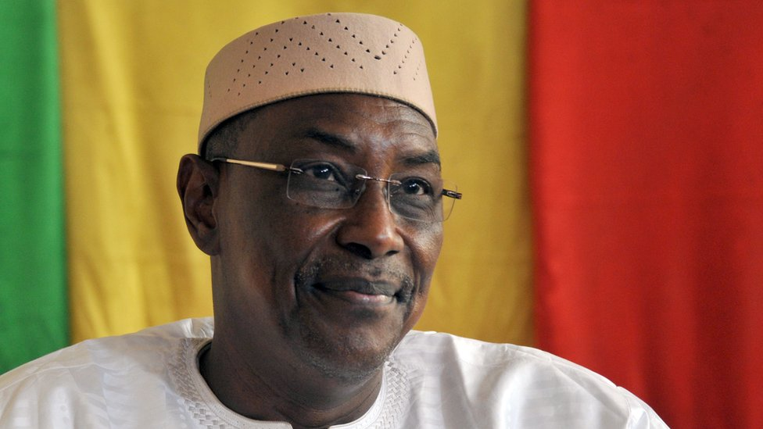image copyrightAFP/Getty Images

image captionPrime Minister Abdoulaye Maiga is seen as a close ally of President Ibrahim Boubacar Keita

**2017** February - Malian soldiers and rival militia groups including Tuareg separatists take part in a joint patrol, a key part of a peace agreement reached in 2015.

**2017** April - President Ibrahim Boubacar Keita announces a new government, appointing close ally Abdoulaye Idrissa Maiga as prime minister.

**2017** June - Al-Qaeda-aligned group Nusrat al-Islam wal Muslimeen claims responsibility for an attack on an hotel popular with Westerners east of Bamako, killing two civilians.

**2018** January - Some 14 soldiers are killed in a suspected Islamist attack on a military base at Soumpi. Elsewhere, 26 civilians die after their vehicle hits a landmine.

**2018** July - President Keita is re-elected as jihadist violence continues to plague the north and east of the country.

**2020** August - President Keita is overthrown in a military coup after months of protests demanding his resignation.